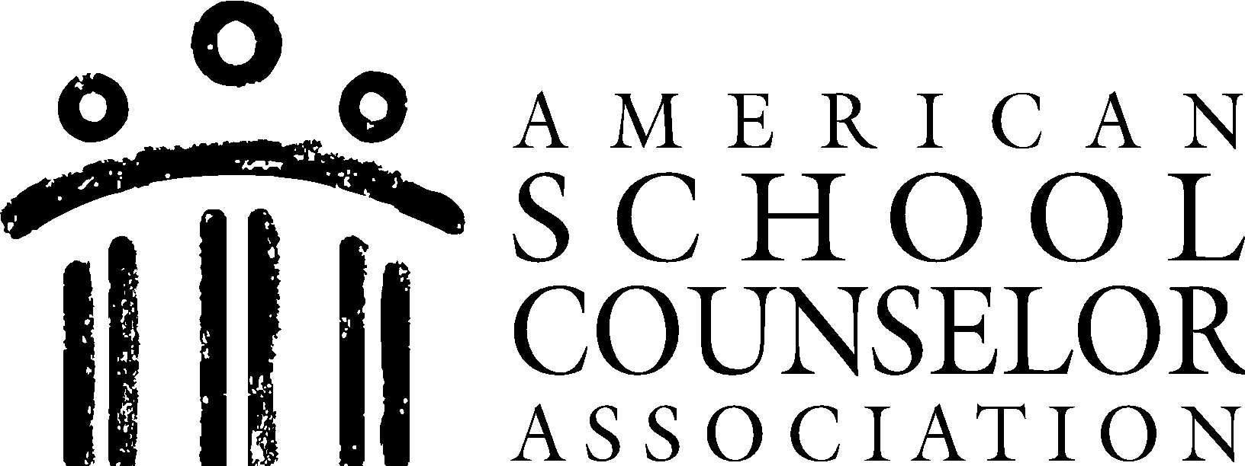 Career Lesson Plan

Presenter: | School Counselor/Career Specialist
Lesson Plan Title: | Career Values  (Created by: Meredith Brown)

ASCA Student Standards Targeted: |  | Student Learning Objectives:
Identify 1–2 student standards relevant for this targeted group and goal:  (Best practice = select one) |  | For each of the selected student standards, write or select 1–2 learning objectives
M&B# | Mindsets & Behaviors Statement | Student Learning Objectives
1.  2. | Career Development and Exploration  Social and Emotional Learning | Student(s) will:  - Identify and explore personal values, interests, and goals that are relevant to career goals.  - Emphasize the importance of self-awareness and decision making.

Materials:
Student Career Values Card Sort- balancedcardsorts.com
Student Career Values Card Sort- Instructions and Workbook (balancedcardsorts.com)

Describe how you will:
Introduce Lesson Topic/Focus: | Begin with a thought-provoking question about career thoughts, discuss career aspirations, the meaning of values, discuss real-world examples, encourage questions and reflection.
Communicate the Lesson Objective: | Review the lesson objectives, define career values and why this is important for students’ futures, relate this to life decisions, and encourage active participation.
Teach Content: | Make this a thoughtful and interactive lesson. Set students up with a values exploration activity (place a visual example of a career value such as (reward) and ask students to choose ones that resonate most with them. Do a personal values reflection, class discussion, and a plan of action to make their career values come to life.
Practice Content: | Students can record their career values within their “Student Career Values Card Sort: Instructions and Workbook.” They can review their results at a later point of time.
Summarize/Close: | Conclude and summarize the importance of understanding one’s values in career-decision making. Assign homework (optional) such as a personal reflection on what students have learned and how it might influence their future choices.

Career Lesson Plan

School Counselor: | School Counselor/Career Specialist
Lesson Plan Title: | Major Career Exploration  (Created by: Meredith Brown)

ASCA Student Standards Targeted: |  | Student Learning Objectives:
Identify 1–2 student standards relevant for this targeted group and goal:  (Best practice = select one) |  | For each of the selected student standards, write or select 1–2 learning objectives
M&B# | Mindsets & Behaviors Statement | Student Learning Objectives
1.  2. | Career Development and Exploration  College and Career Readiness | Student(s) will:  1.) Assess and analyze their interests, strengths, values, and goals to make informed career decisions.  2.) Demonstrate readiness for future education and career development opportunities by developing career and employability skills.

Materials:
Computer (Focus II Assessment)

Describe how you will:
Introduce Lesson Topic/Focus: | Open the lesson with the impact this assessment serves to students, define what the assessment is, highlight its significance, relate this to your students and personal success stories, encourage motivation and inspiration,
Teach Content: | Provide a brief reminder as to the greater purpose of this lesson, define what each assessment means and the expectations. Provide visual aid and an example of a successful completed Focus II results.
Practice Content: | Students can create plans of actions based on their Focus II results. Reinforce the concept of taking Focus II and the impact of career planning.
Summarize/Close: | Wrap up by summarizing the importance of this assessment. Reiterate the goals that you are ready to accomplish with your students such as personal growth, commitment, and career exploration.

Career Lesson Plan

School Counselor: | School Counselor/Career Specialist
Lesson Plan Title: | SMART Goals for the Present and Future  (By: Meredith Brown)

ASCA Student Standards Targeted: |  | Student Learning Objectives:
Identify 1–2 student standards relevant for this targeted group and goal:  (Best practice = select one) |  | For each of the selected student standards, write or select 1–2 learning objectives
M&B# | Mindsets & Behaviors Statement | Student Learning Objectives
1.  2. | College and Readiness  Life Skills and Personal Development | Student(s) will:  - Set specific, measurable, achievable, relevant, and time-bound (SMART) goals to plan for and achieve future educational and career aspirations.  - Demonstrate the ability to create and follow a plan that includes SMART goals, adapt to changing circumstances, and manage time effectively to achieve their personal and academic aspirations.

Materials:
writing utensil
paper or this can be done electronically
SMART goals worksheet (optional)

Describe how you will:
Introduce Lesson Topic/Focus: | Start with a personal story or quote, define SMART goals and relate this to personal aspirations or goals, emphasize the need and express the importance. Encourage active questions and set realistic expectations.
Communicate the Lesson Objective: | Utilize a combination of clear and concise explanations and visual aids. Make sure students have a clear understanding of SMART goals.
Teach Content: | Begin by defining SMART goals with a visual presentation to illustrate each component followed by specific real-world examples. Express the benefits and relevance for where students are at in school.
Practice Content: | You can offer a goal setting journal (optional) and hold students accountable for what they have written. Do frequent check-ins with these students.
Summarize/Close: | Review key points covered within this lesson. Continue showcasing student examples with allocated time for reflection and questions. End with some final inspiration whether it be a successful story related to goal setting or an inspiring quote.

Career Lesson Plan

School Counselor: | School Counselor/Career Specialist
Lesson Plan Title: | Beach Ball Activity - Overcoming Adversities  (By: Meredith Brown)

ASCA Student Standards Targeted: |  | Student Learning Objectives:
Identify 1–2 student standards relevant for this targeted group and goal:  (Best practice = select one) |  | For each of the selected student standards, write or select 1–2 learning objectives
M&B# | Mindsets & Behaviors Statement | Student Learning Objectives
1.  2. | Self-awareness of their perceptions and  others around them  Social and cooperative skills | Student(s) will:  - Demonstrate and apply their feelings or recollect their deepest memories.  - Students will socially collaborate with their classmates and share their insights.

Materials:
Beach ball with a sharpie

Describe how you will:
Introduce Lesson Topic/Focus: | Review the objectives and what students will gain from this activity. The ability to engage students in an open discussion centered around the idea of how they have overcome challenging times.
Communicate the Lesson Objective: | Begin by emphasizing the importance of being present with your emotions and feelings towards experiences students have had.
Teach Content: | Explain that you have a beach ball with questions/prompts related to their personal challenges or adversities. The students can then answer and share these with the group.
Practice Content: | Assign a reflection prompt as their homework (optional). Do a check in with what they have learned.
Summarize/Close: | Explain the importance of recognizing resilience. Fun and engaging activity that allows students to practice their social skills and collaboration skills. This topic can be centered around academic challenges.

Career Lesson Plan

School Counselor: | School Counselor/Career Specialist
Lesson Plan Title: | Identifying your Role (Rainbow Activity)  (By: Meredith Brown)

ASCA Student Standards Targeted: |  | Student Learning Objectives:
Identify 1–2 student standards relevant for this targeted group and goal:  (Best practice = select one) |  | For each of the selected student standards, write or select 1–2 learning objectives
M&B# | Mindsets & Behaviors Statement | Student Learning Objectives
1.  2. | Social Responsibility  Social and Emotional Learning | Student(s) will:  - Identify their roles and responsibilities as active and engaged citizens in their communities, including understanding how their actions can contribute to the betterment of society.  - Develop self-awareness, including understanding their personal strengths, values, and interests, which contribute to their roles in relationships and society.

Materials:
paper
colored pencils

Describe how you will:
Introduce Lesson Topic/Focus: | Ask students what kind of responsibilities they have; Are they working, a daughter, a son, etc. Define the lesson: The concept of exploring and identifying your role. Emphasize it’s important to recognize your role to see what you take on and to have a balance. Provide realistic examples.
Communicate the Lesson Objective: | Hold a group discussion asking students to share their thoughts about identifying one’s role in society and personal lives. Define roles: (Personal, family, school, community, and society), allow for personal reflection.
Teach Content: | Define key concepts such as “roles” and “responsibilities.” Explain how students will draw a rainbow with a pencil and within each color/tile have the students shade in how much time their everyday life is spent being a student, or a friend, etc. They can write their role down within each tile.
Practice Content: | Have students on a daily basis continuously be in tune with their lives and responsibilities. Enhance the concept of work/life/balance and career wellness.
Summarize/Close: | Summarize the key points while allowing students to share their insights. Encouraging action that emphasizes the knowledge of their role is the first step. Encourage students to take action to fulfill their roles (school, community, future career) or eliminate responsibilities if their balance is overloaded.

Career Lesson Plan

School Counselor: | School Counselor/Career Specialist
Lesson Plan Title: | Self Care Action Plan  (By: Meredith Brown)

ASCA Student Standards Targeted: |  | Student Learning Objectives:
Identify 1–2 student standards relevant for this targeted group and goal:  (Best practice = select one) |  | For each of the selected student standards, write or select 1–2 learning objectives
M&B# | Mindsets & Behaviors Statement | Student Learning Objectives
1.  2. | Social and Emotional Learning  Career Wellness | Student(s) will:  1. ) Develop self-awareness and self-management skills to achieve school and life success.  2.) Demonstrate the ability to practice self-care strategies that promote physical, mental, and emotional well-being.

Materials:
An online printed template of a self care action plan

Describe how you will:
Introduce Lesson Topic/Focus: | Begin the lesson with a real-life scenario or story related to the importance of self-care. Define self-care and its importance. Use relatable examples to illustrate what self-care means and why it's essential. Provide students with a self-reflection worksheet or journal prompts. Ask them to reflect on their daily routines, stressors, and areas where self-care could be beneficial.
Communicate the Lesson Objective: | Start the lesson with a personal story or anecdote related to the importance of self-care. Define self-care and its significance. Provide students with a self-care assessment tool or questionnaire.
Teach Content: | Discuss major career exploration and how the further they move along with school, their interests will change and develop.
Practice Content: | Encourage students to start implementing their self-care action plans immediately. Discuss the importance of action steps. You can facilitate group check-ins with your students and offer helpful resources such as guest speakers, reviewing and updating action plans, self-care challenges, and self-care workshops.
Summarize/Close: | Summarize the importance and immediate actions students can decide to embark on. Stress the value of taking care of yourself and how this correlates with career/academic successes!

